

February 16th, 2024

PLANNING AND PROGRESS REPORT

**Repository: https://github.com/C1-010/Acme-SF-D01**

Group: C1.010

García Rivero, Andrés - [andgarriv@alum.us.es](mailto:andgarriv@alum.us.es)

López Cubiles, Antonio José - [antlopcub@alum.us.es](mailto:antlopcub@alum.us.es)

Nieto Vicioso, Javier - [javnievic@alum.us.es](mailto:javnievic@alum.us.es)

Díaz Ordoñez, Pablo -  [pabdiaord@alum.us.es](mailto:%20pabdiaord@alum.us.es)

Sevillano Barea, Alejandro - [alesevbar@alum.us.es](mailto:alesevbar@alum.us.es)

Content Table

1. Executive Summary 2

2. Revision Table 2

3. Introduction 2

4. Contents 2

5. Conclusions 2

6. Bibliography 2

# 1. Executive Summary

# This report provides a comprehensive overview of my progress and activities during the project's development in this deliverable. Key tasks undertaken include setting up the development environment and implementing the initial mandatory functional requirement. Despite encountering challenges such as extended installation times, satisfactory progress was achieved. Tasks were completed within the designated timeframe, with documentation provided through screenshots. Additionally, a budget was estimated, considering work hours and associated costs. The report aims to outline the progress made and establish a foundation for future project iterations. The document structure includes detailed planning, progress tracking, and conclusions drawn from this milestone execution.

# 2. Revision Table

|  |  |  |
| --- | --- | --- |
| Revision number | Date | Description |
| 1 | [16/02/2024] | Beginning of the report. All sections completed. |
| 2 |  |  |

# 3. Introduction

This report offers a detailed insight into my progress and planning efforts throughout the project's development. During this period, I undertook critical tasks to establish the necessary work environment and implement the initial mandatory functional requirement.

Despite encountering challenges, such as longer than expected installation times, I managed to make satisfactory progress. Tasks were allocated and completed within the designated timeframe, with screenshots recorded to document delivery statuses at various development stages.

Additionally, I estimated a budget considering work hours and associated costs. The aim of this report is to provide an overview of the progress achieved to date and establish a solid foundation for future iterations of the project.

Furthermore, the document structure includes a detailed description of the planning conducted, progress made, and conclusions drawn from this milestone execution.

# 4. Contents

4.1 Planning

**Environment Installation:**

Title: Development Environment Setup.

Description: Download and install all necessary tools for project development, including Eclipse, Java, DBeaver, MariaDB, Firefox Developer Edition, and GeckoDriver, among others.

Assigned and Role/s: Me – developer.

Planned Time: 2 hours.

Actual Time: 5 hours.

**Implementation of the First Mandatory Functional Requirement:**

Title: Implementation of the mandatory functional requirement for the favorite website.

Description: Modify the anonymous menu to add an option redirecting to each user's favorite website's homepage, following the specified format.

Assigned and Role/s: Me – developer.

Planned Time: 30 minutes.

Actual Time: 40 minutes.

**Creation of Reports using the template:**

Title: Designing individual reports.

Description: Create project reports and fulfill their executive summaries, introductions, content sections, conclusions, and bibliographies.

Assigned and Role/s: Me – Developer.

Planned Time: 2 hour 30 minutes.

Actual Time: 1 hour.

**Screenshots**

Initial screenshot of tasks in the “to do” column:

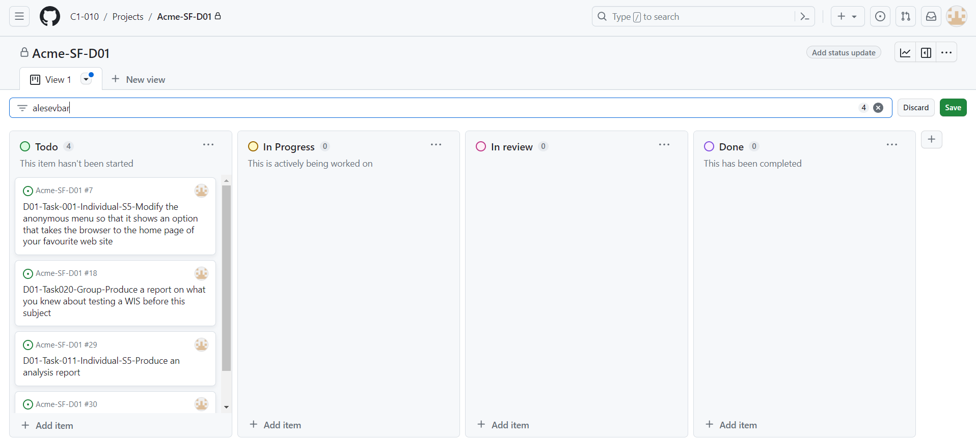

Intermediate screenshot of tasks in the process to be completed:

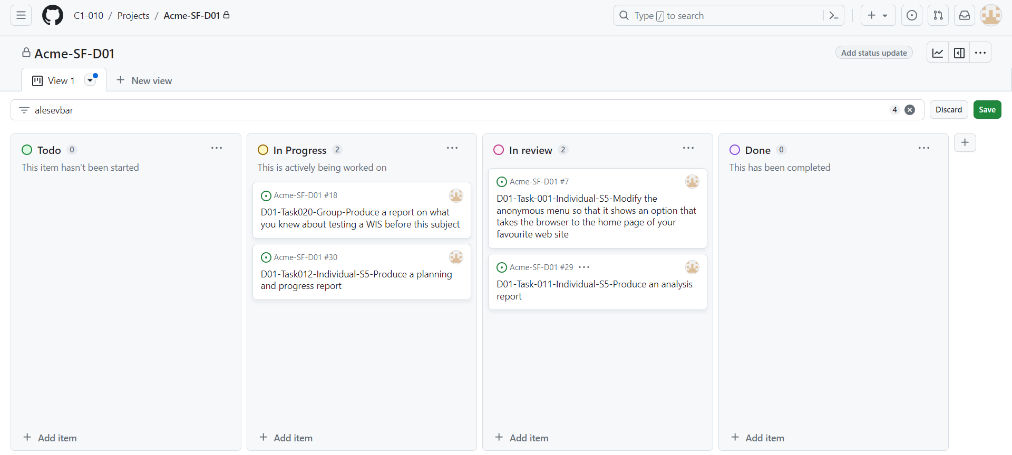

Screenshot at the end of the deliverable with all placed in the 'Done' column:

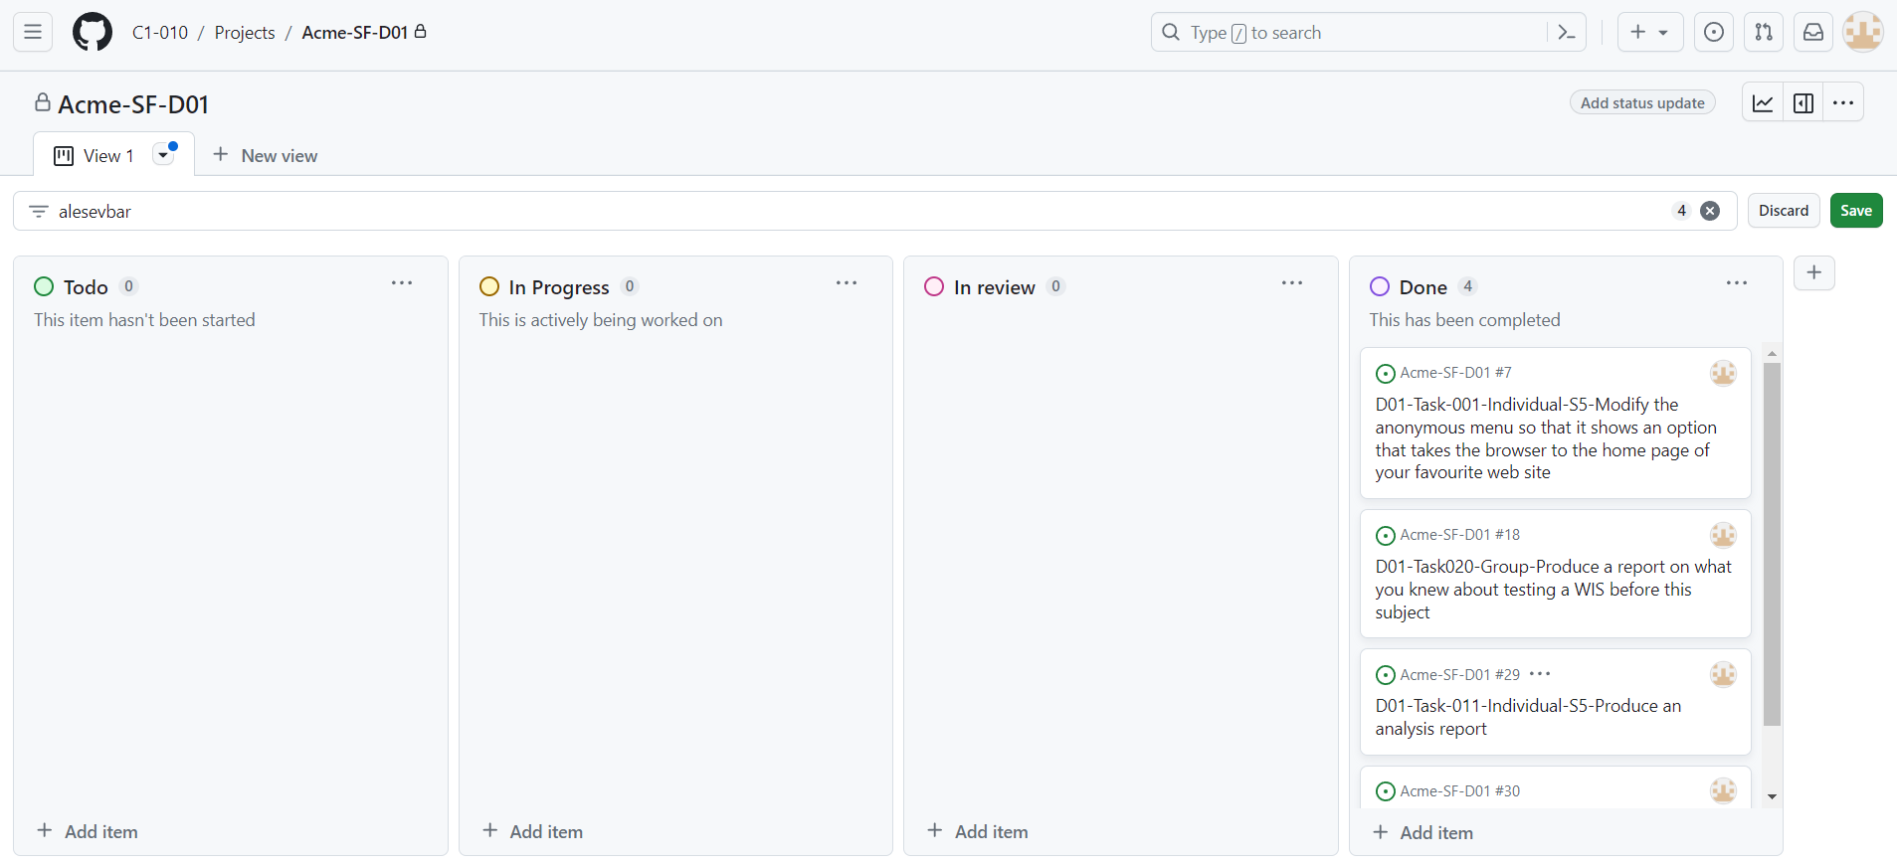

**Budget:**

Total Number of Estimated Hours:

• Environment Installation: 2 hours

• Implementation of Functional Requirement: 30 minutes

• Creation of reports and templates: 2 hours and 30 minutes

Personnel Cost:

• Front-end Developer: (2 hours + 30 minutes + 2 hours and 30 minutes) x €20.00/hour = 100,00€

• Total Estimated: 100,00€

4.2 Progress

**Progress Record:**

Team Member: Nieto Vicioso, Javier.

Performance Indicator/s: Performing well.

Performance Consideration: Good.

Brief Description of Applied Reward or Admonition: Javier consistently completed over 90% of his assigned tasks within the specified timeframe, demonstrating excellent efficiency and productivity.

Team Member: García Rivero, Andrés

Performance Indicator/s: Performing well.

Performance Consideration: Good

Brief Description of Applied Reward or Admonition: Andrés consistently completed over 90% of his assigned tasks within the specified timeframe, demonstrating excellent efficiency and productivity. Additionally, he did a great job as a Manager.

Team Member: López Cubiles, Antonio José.

Performance Indicator/s: Performing well.

Performance Consideration: Good.

Brief Description of Applied Reward or Admonition: Antonio José consistently completed over 90% of his assigned tasks within the specified timeframe, demonstrating excellent efficiency and productivity.

Team Member: Díaz Ordoñez, Pablo.

Performance Indicator/s: Performing well.

Performance Consideration: Good.

Brief Description of Applied Reward or Admonition: Pablo consistently completed over 90% of his assigned tasks within the specified timeframe, demonstrating excellent efficiency and productivity.

**Conflict and Resolution:**

There haven't been any conflicts with any group member thus far, but individually, I have some issues with environment setup that have mostly been resolved with team active collaboration.

**Cost Comparison:**

Total Number of Real Hours:

• Environment Installation: 5 hours

• Implementation of Functional Requirement: 40 minutes

• Creation of reports and templates: 1 hour

After making the deliverable, a comparison was made between the estimated cost in the previous planning and the actual cost. Details include the number of hours spent, personnel costs, and amortization costs, as outlined below:

• Front-end Developer: (5 hours + 40 minutes + 1 hour) x €20.00/hour = 133,33€

•Total Estimated: 133,33€

# 5. Conclusions

# The project's development phase has brought significant progress despite setbacks such as installation issues. Tasks, including setting up the development environment and implementing the initial functional requirement, were completed within the estimated time. Team members consistently exceeded the 90% task completion benchmark, demonstrating their efficiency.

# Although actual costs varied slightly from the estimates, they remained close. This underscores the importance of precise planning.

# Overall, this phase establishes a strong foundation for future project iterations, emphasizing the need for dedication from everyone and collaboration among us.

# 6. Bibliography

Intentionally blank.